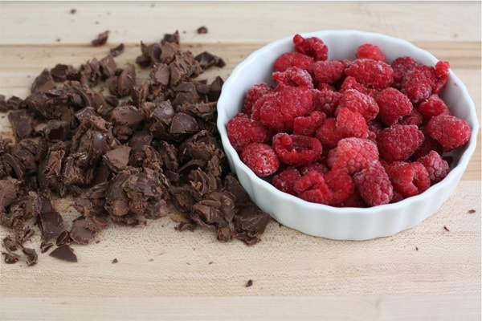

~ FEBRUARY COFFEE SPECIAL ~

RASPBERRY TRUFFLE LATTE
(GREAT FLAVORS TOGETHER – ESPRESSO WITH RICH CHOCOLATE AND RASPBERRY)

